20/11/25 10am (Session 1-2)
Summary of what I’ve taken from the introductory slides:
What why when:
-> using existing PIC code written in Python, conduct plasma physics study.
-> various tasks on VLE, broken into separate sections
-> Sessions run flexibly, don't need to be in the room, don't need to be in front of computer all day
-> ~28 hrs of work ish (30 max)

Assessment:
- google doc lab book
- pass/fail
- assessment based entirely off lab book, submitted through VLE as pdf
- much better to submit a succinct, high quality record, rather than a verbose, low quality one.

Quick start guide:
- implements PIC algorithm in 1D periodic domain, using RK4 for time integration and FFTs for spatial derivatives (SEE LECTURES 7 AND 8 OF COMP TECHNIQUES!!!!!)
- primary use of code = look at wave-particle interactions
- Two main physics phenomena explored in the tasks
- Landau damping: transfer of Energy from wave to plasma
- two stream instability: transfer of Energy from plasma to wave

Tips:
- code can be quite slow, can you speed it up???
- DONT FORGET ERRORS AND UNCERTAINTIES!!!
- PIC suffers from noise (t.f. may need lots of repeats which may generate lots of data).
- How should I handle this???
- Split into 2 stages:
- generation of raw data by running code -> save raw data
- analyse that raw data. i.e. measure derived quantities from save draw data using anal. code.

First Steps:
- review tasks
- read up a lil on wave-particle interactions
- produce summary in lab book
- read through code and produce summary of key sections in lab book
- lecture 8 probs most helpful but lecture 7 can help (comp techniques)
- check you can run code and what the screen output looks like
- produce data management plan
- GIT!!!!!
- modify code to save the relevant data
- how will you organise the data?
- make a plan for how you'll tackle the tasks

Data Management Plan
Github Repository is now set up
All coding and analysis will be done using Visual Studio (VS) code, using the source control functionality to backup data and code versions on Github.

Session Plan:
- Set up github repository and begin lab book entries
- Download and run code
- Complete ‘Session 1-2: Tasks and Activities’

20/11/25 3pm (Session 1-2)
Summary of code functionality
What is Landau Damping?
- Broadly : A mechanism where oscillations in a charged medium are damped by non-collisional interactions with said medium.
- More specifically, Landau damping occurs due to the energy exchange between and EM wave (with a phase velocity v_{ph}) and particles in the plasma (the charged medium) with a velocity ~ v_{ph}. These particles interact strongly with the wave, as particles with a velocity slightly less than v_{ph} get accelerated by the E-Field of the EM wave, while particles with velocity slightly more than v_{ph} get decelerated. This synchronises the particle velocity with the phase velocity of the wave, which prevents instabilities from developing, creating a region of stability within the parameter space.
- Consider the particle velocities to be approximately Maxwellian – i.e. let the plasma be governed by ideal MHD. If the slope of the function <1, the no. of particles with velocities slightly less than v_{ph} is greater than the no. with velocities slightly greater. This results in wave damping (‘Landau Damping’!)as there are more particles gaining energy from the wave than losing energy to it. AND VICE VERSA -> ‘Landau Growth’!
[insert diagram here]
- A nice analogy is the surfing situation:
  - Let Langmuir waves be the sea, and consider the charged particles to be surfers trying to catch the wave.
  - If the surfer is moving at a velocity < v_{ph} , they see the wave approaching from behind, with the wave crest pushing them forward. i.e. they gain energy from the wave, thus the wave loses energy.
  - If the surfer is moving at a velocity > v_{ph} they can be considered as swimming into the crest of the wave, essentially climbing it. i.e. they are losing kinetic energy while the wave is gaining energy.
  - In a Maxwellian distribution, there are more particles with velocities < v_{ph} , thus the slower group dominates and drains energy from the wave, resulting in an overall wave damping effect -> Landau Damping!
  - Worthy to note that only surfers contribute to this effect, as a beachball (for example) floating on the water with zero velocity will simply bob up and down as the wave passes by. In other words, particles very far from v_{ph} oscillate rapidly in and out of phase, so even though they may gain energy in one part of the oscillation cycle, they return it in the next, resulting in a net zero effect over a period.

Initial Experiments with Code
- Simulation runtime with animation : 6.467 seconds
- Simulation run time without animation : 2.110 seconds
- Improvement : 4.357 seconds or 67.372%
- First harmonic data is saved in 2 stack columns (time | first harmonic) as harmonic_data.txt
Assessing the noise
Plan of Action (POA)
- Load or reference harmonic data.
- Detect peaks -> produce arrays of peak times/amps.
- Plot signal + peaks overlay.
- Loop through peaks to find where noise dominates.
- Split data into signal peaks + noise peaks.
- Compute noise metric.
- Print or plot result.
The code according to the POA gives the following results:
--- NOISE ANALYSIS ---
Noise starts at peak index: 3
Estimated noise amplitude: 0.03467561350424121

--- FREQUENCY MEASUREMENT ---
Estimated ω = 2.053 ± 0.137

--- DAMPING RATE ---
Estimated γ = 0.196 ± 0.075

--- COMPARISON ---
Analytic: ω = 1.416, γ = 0.153
Typical PIC: ω = 1.33 ± 0.16, γ = 0.168 ± 0.002

simulation runtime: 8.539 seconds
Initial Analysis:
- Noise dominates after the third peak (fig.1). This gives a signal window that’s usable, but short. This can be expected for a low-particle 1D PIC run.
- Later peaks are dominated by particle fluctuations, not damping, as indicated by the noise floor of ~ 3e-2.
- Does the measured ω overshoot analytical/typical PIC values?
- Is γ too high? Is it consistent with analytic and reference PIC values, given the noise-driven uncertainty?
- Longer runs/more particles would tighten estimates and reduce bias.

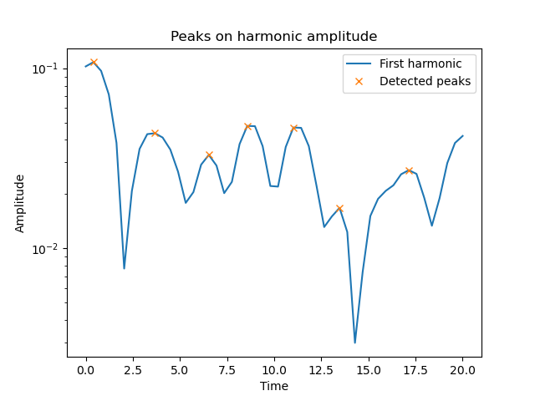
Fig.1 Plot of the First Harmonic Normalised Signal Amplitude with detected peaks overlay. Noise dominates when a peak is larger than the one preceding it. This disagrees with damping, indicating that the signal is being driven by noise.

27/11/25 11pm (Session 2-3)
Goal of the Session
Explore how noise level, wave frequency and damping rate change as you change the number of cells, the number of particles and the length of the box.

Statistical Variation
- Run 5 sims with same initial conditions
- Measure the noise, frequency and damping rate for each run.
- compute a mean with appropriate error estimate.
- Compare the error on repeat measurements to the error on an individual measurement. Which is most significant?
General idea for code:
- Ask user for N runs (via input() or CLI arg).
- Loop N times.
- For each run:
  - run the simulation
  - extract noise, ω, γ
  - save results to a unique file
- After the loop:
  - compute means + standard deviations
  - print comparison (individual‐run error vs ensemble error)

Code Results:
Noise : mean=0.03693, std=0.01041
Omega : mean=2.403, std=0.5554
Gamma : mean=0.1887, std=0.04362

--- ERROR COMPARISON ---
Individual ω error : 0.1642
Run-to-run ω spread: 0.5554
Individual γ error : 0.04336
Run-to-run γ spread: 0.04362

Larger value = dominant source of uncertainty.

